1. **Refer below link to download and install azure cli on linux machine.**

Prefer Microsoft Installer(MSI)

<https://learn.microsoft.com/en-us/cli/azure/install-azure-cli-windows?pivots=msi>

1. Command to create resource group from azure cli.

#az group create --name **testcli** --location eastus

1. Command to create vm from azure cli.

#az vm create --resource-group **testcli** --name **test** --image Ubuntu2204 --vnet-name $vnetName --subnet **example-subnet** --generate-ssh-keys --output json –verbose

1. To know more about azure cli.

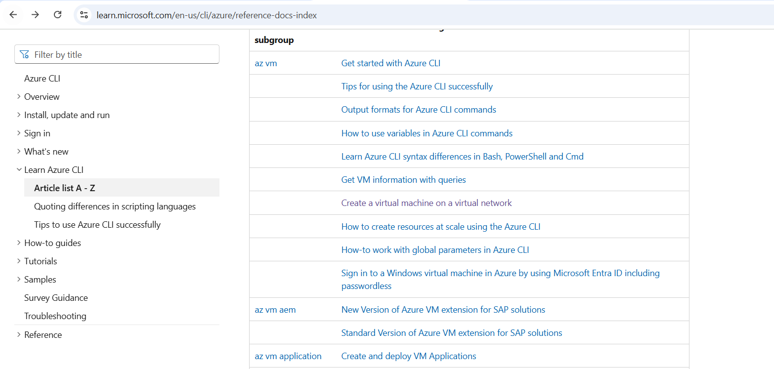

1. Any resource creation technique like Azure UI/CLI/ARM template/BICEP/SDK will talk to the **azure resource manager** first to create resources on azure platform.

Azure resource manager maintains the standardization. This is a primary advantage for azure resource manager.